Divergence and candle sticks
forexfactory

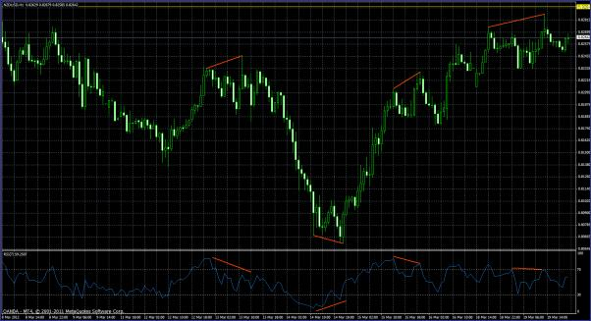
This system does not use any indicators except for the RSI as an oscillator. The RSI is used as a divergence "leading" indicator to "predict" possible price reversal point. In addition we will also look for a candle stick reversal pattern to solidify our decision. To make things more concrete, we will also look to see these reversal levels are occurring at a logical reactionary price levels, making our odds at winning the trade that much better.

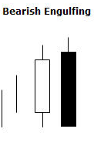
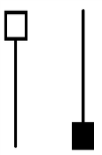
Regular Divergence Rules
For short setup:
Pin Bar
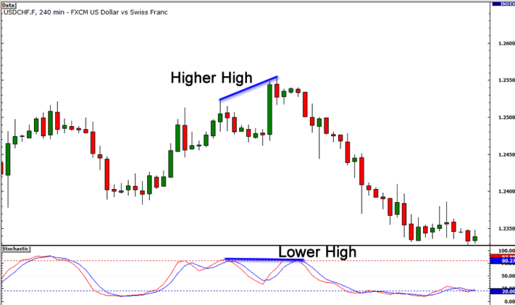
1- We look for the price to form a pin bar or bearish engulfing candle stick pattern.
2- We now look at RSI(7) of the price close (or wipe) to see if there is divergence between it and the price. i.e. the price has made a higher high but the RSI either stayed level or made a lower high.
3- Look to see that the RSI has gone above the 70_level where the first point of divergence is drawn.
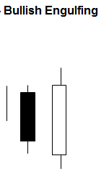
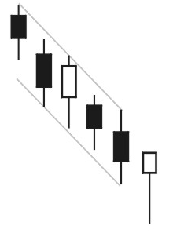
4- Now, zoom out a bit and look to see the level where all this is occurring. Is it around a round number, or previous support/resistance level? Is it at a fib ratio? This gives us more confidence in the trade, but it doesn’t have to be present.
Hammer

For Long setup:
1- We look for the price to form a hammer or bullish engulfing candle stick pattern.
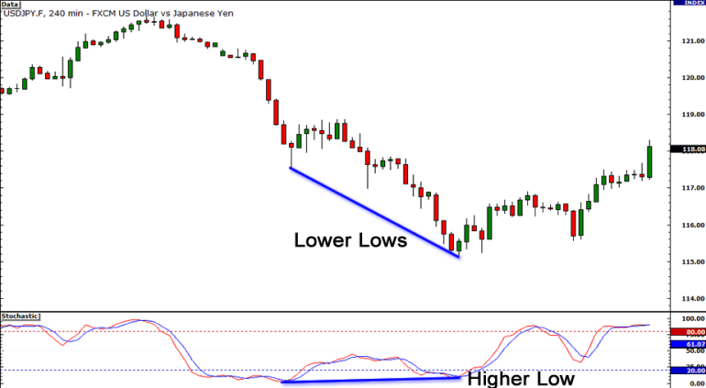
2- We now look at RSI(7) of the price close (or wipe) to see if there is divergence between it and the price. i.e. the price has made a lower low but the RSI either stayed level or made a higher low.
3- Look to see that the RSI has gone below the 30 level where the first point of divergence is drawn.
4- Now, zoom out a bit and look to see the level where all this is occurring. Is it around a round number, or previous support/resistance level? Is it at a fib ratio? This gives us more confidence in the trade, but it doesn’t have to be present.

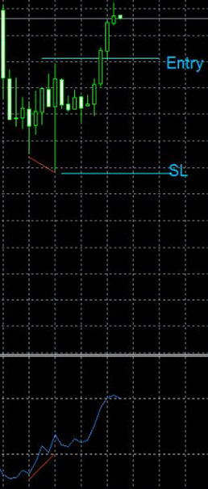
Specification
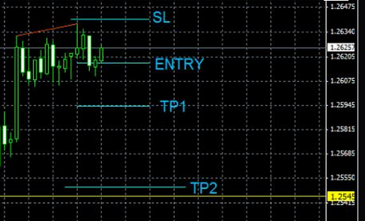
Entry is a couple of pips above the high/below the low of the bar. I do not wait for another bar to confirm as the pin bar or engulfing bar is already a good enough sign for entry.
I set my SL a few pips below/above the opposite side of the candle. TP1 to be the same as SL, and TP2= 2 X SL or next support/resistance level and moving SL to BE.

1-Don’t trade in a strong trend market, nether when price is choppy, wait for swing price movement.
2-London and us overlap is the best market condition,
3-Don’t trade against strong trend
4- Look for a zone of support and resistance for past few candles.
5-Look for head and shoulder pattern but be careful for trend continuation.

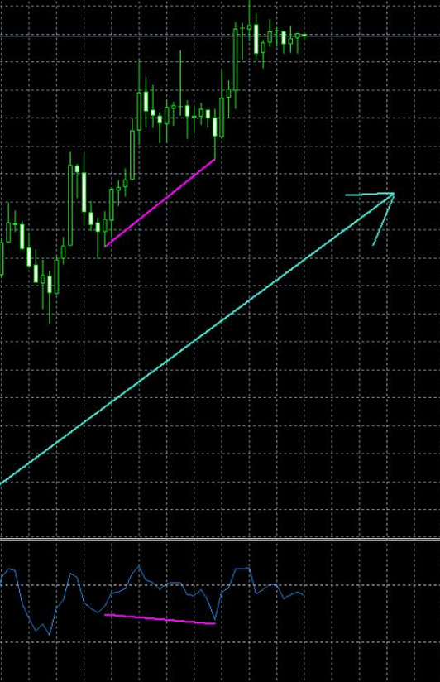
Hidden divergence
In an uptrend, the price will make a higher low, but the oscillator will make a lower low or stay flat.
In a downtrend, the price will make a lower high, but the oscillator will make a higher high or stay flat.
To trade this, you are likely to look for price continuation candle formations, at hidden divergence levels along with possible reactionary price levels such as support/resistance, pivot points, round numbers, channels and trendlines.

